**SHADOW:**

Idle:



Jump:

Walk:

Run:

Attack 1:

Attack 2:

Attack 3:

Charge attack:

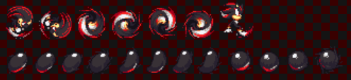

Block:

Get hit and fall:

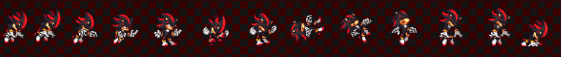

Get launched:

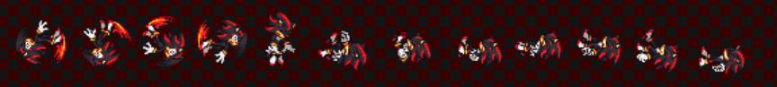

Recover:



**TRUNKS:**

Idle:

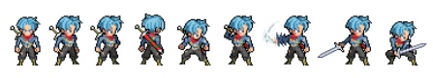

Jump:

Move front:

Move Back:

Attack 1:

Attack 2:

Attack 3:

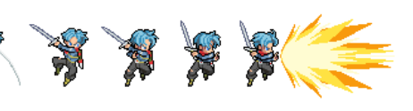

Charge Attack:

Block:

Get hit:

Get launched:

Recover:

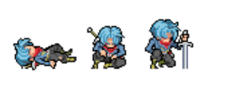

**FRIEZA:**

Idle:

Jump:

Move front:

Move Back:

Attack 1:

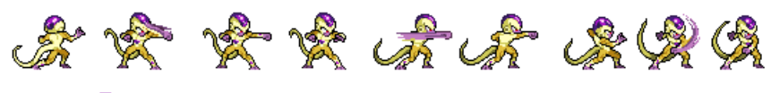

Attack 2:

Attack 3:

Charge attack:

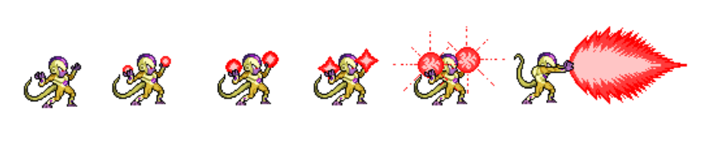

Block:

Get Hit:

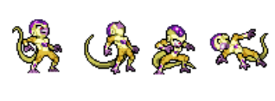

Get Launched:

Recover:

**Knuckles:**

Idle:

Jump:

Walk:



Run:

Attack 1:

Attack 2:

Attack 3:

Charge attack:

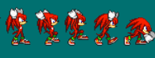 

Block:

Get hit:

Get launched:

Recover:

